Flower Brooch
”Secret pond”
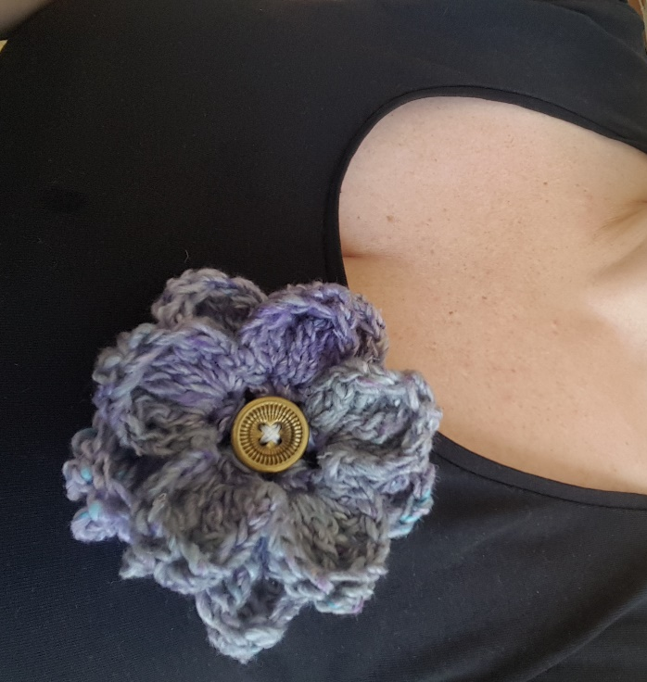

I had a bit of leftover yarn after finishing a shawl and since I think the yarn is kind of romantic, I thought that a flower brooch would be a perfect make of the scraps.
The yarn is “Secret Garden” from Scheepjes and is made of 20 % silk, 20 % cotton, and 60 % polyester. It’s soft yet still looks a bit rough. Of course you could choose any yarn for this flower, it’s a perfect scrapproject!
Material
Yarn: Scheepjes Secret garden, I’ve used color # 709: Lily Pond.
Hook: 4 m.m.
Gauge: Not important
Storlek: The flower measures approx. 8 cm.
Övriga tillbehör: 1 button and a pin.

Stitches used: (American)
Ch: chain
sl st: slip stitch
sc: single crochet
hdc: Half double crochet
dc: double crochet
tr: treble crochet
dtr: double treble crochet
Trtr: Triple treble crochet
sk: skip

Start
Ch 4, Join with a sl st to form a ring.
Round 1: In the ring: ch 3 (=1 dc, ch 1), *2 dc, ch1* repeat *-* 4 times. End with: 1 dc, ch 1, sl stin 2nd chain. (Total of 10 dc (5 pairs of st) and chain 1 between each pair.)
Round 2: sl st in chst, *in next dc: (1 sc, 1 hdc, 1 dc, 1 tr, 1 dtr, 1 trtr) in next dc: (1 trtr, 1 dtr, 1 tr, 1 dc, 1 hdc, 1 sc.) sk ch* repeat *-* 4 times, making a total of 5 petals.
Turn the flower, so that the back is facing you.
Round 3: sl st around a pair of dc. *ch 3, 1 sc around next pair of dc*. Repeat *-* 4 times, end with ch 3 and a sl st in the first sl st. (You now have 5 sc with 5 ch 3 in between2 .)
Turn the flower again so that the right side is facing you and bend the petals forward so that you can reach the chains
Round 4: (1 sc, 1 hdc, 1 dc, 1 tr, 1 dtr, 2trtr, 1 dtr, 1 tr, 1dc, 1 hdc, 1 sc.) in each chain, making five petals.
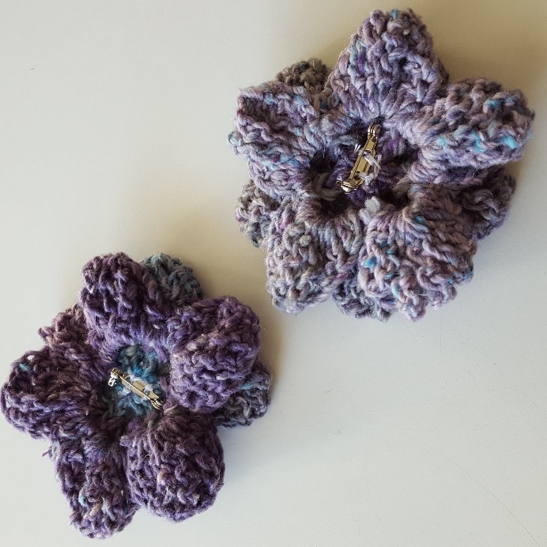

Finishing
Weave in all the ends. Sew on a pin and button with sewing tread. If the botton’s holes are big enough it’s nice to use one of the yarn ends to sew with instead of with sewing thread.
Done!
