Iris - shawl
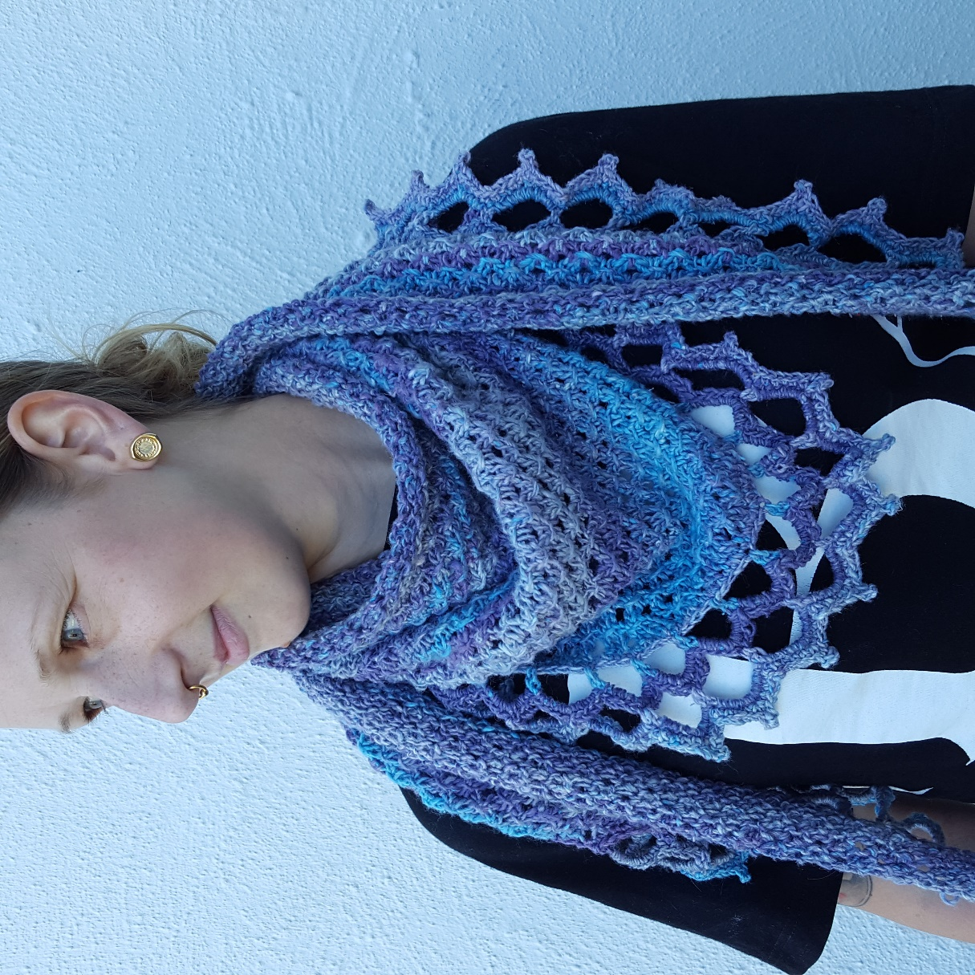
Some yarns just have one purpose, and is perfect for some projects. Secret Garden from Scheepjes is a typical shawl-yarn, I think, and I knew right away when I got it that I wanted to make a triangular shawl. And that I wanted to make it for myself.
Material
Yarn: Scheepjes Secret Garden, 5 balls. (50 gram/ball
Knitting needles: circular needles 4 mm. The longer the better (almost), I used 120cm
Gauge: Not important, but I recommend that you make a swatch of the pattern to make sure the piece won’t feel to compact, in that case you should go up one size on the needles. Crochethook 4 m.m. for the edge.
Size: 125 * 47 cm.
Other things: 2 stitchmarkers that you can open.
Pattern ”knotted Openwork”:
Multiple of 3.
Row 1: purl
Row 2: K2, *yo, k3, with left-hand needle lift first of 3 sts just knitted over last 2* rep *-* to last st. K1
Row 3: purl
Row 4: K1, *k3, with left-hand needle lift first of 3 sts just knitted over last 2, yo* rep. *-* to last 2 sts, k2.
Start:
Cast on 8 sts.
Place marker after the first st and before the last st.
OBS! First and last stitch on every row is knit kfb: Knit in the front loop, but before you let the stitch go you knit another stitch in the back loop.
Start with the pattern on the first row, that is row 1 purl. And don’t forget to kfb in the first and last stitch. To get the hang of how the increases and pattern will work together I’ve written out the first four rows.
Row 1: kfb, (marker) *follow pattern row 1 above, that is: purl until second marker*, (marker) kfb (there is now 2 sts before and after the markers).
Row 2: kfb, knit 1 (marker) *folllow pattern row 2 above until second marker*. (marker) Knit 1, kfb. (There is now 3 sts before and after the markers.)
Row 3: kfb, purl 2 (marker) *follow pattern row 3 until second marker. (marker)* Purl 2, kfb (there is now 4 sts before and after the markers.)
Every time there is 4 sts before and after the markers you move the markers back to 1 st after the 1st st and 1 st before last marker, now incorporating three more sts on each side into the pattern.
Row 4: kfb, (marker) *follow pattern row 4 until second marker* (marker) kfb.
Continue with the four pattern-rows and moving the marker on every third row, as soon as you have 4 sts before and after the markers.
I always write down every row I make, and I repeated the 4 rows 27 times. If you make it bigger you might need additional balls of yarn. (I used the leftovers to make two flower brooches, pattern on my blog.)

Crochet edge
Use 4 mm hook for the edge.
Row 1: Start on the right side, make sc along the bottom edge. It’s hard to say exactly how many, not too closely, and check often to make sure the edge is straight and looks good. Turn.
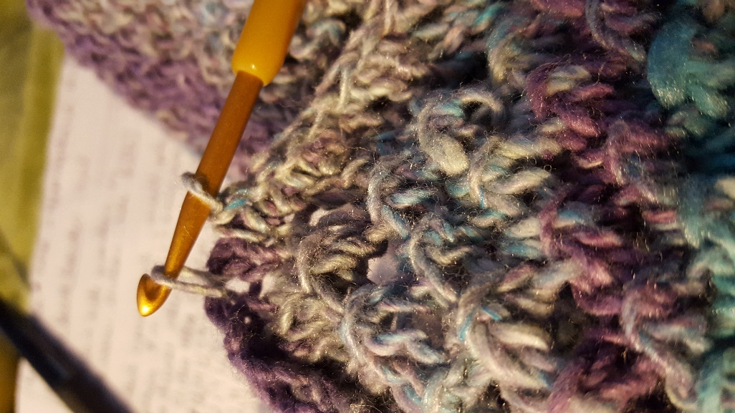
Row 2: * ch 7, sk 3 sts,* repeat *-* until end. (Perhaps it doesn’t end up evenly, but it’s ok if you skip 2 instead of 3 in the end for example.)
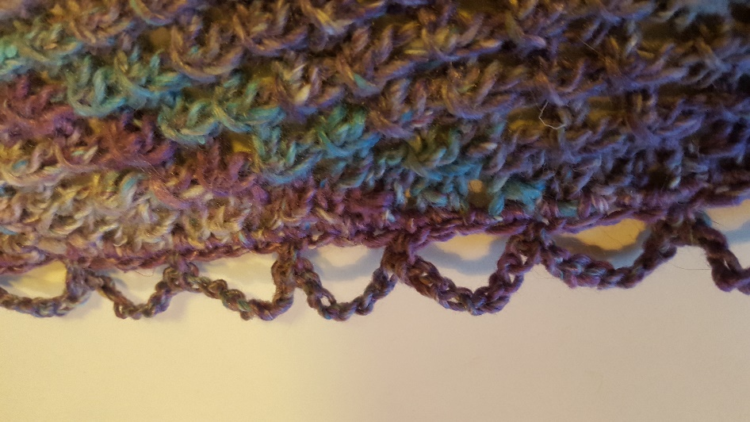
Row 3: 9 sc around each ch 7. Turn.
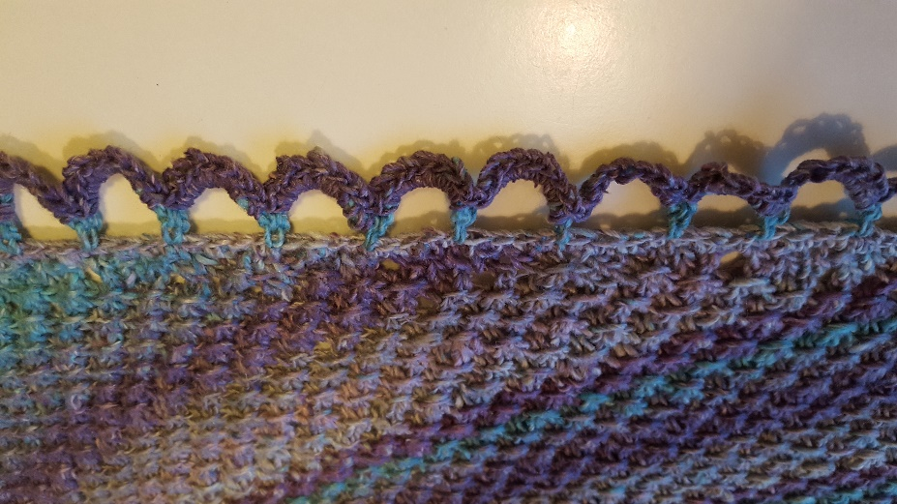
Row 4: 4 sl st so that you reach the top of the chain (=5th of the sc around the ch 7) *ch 7, 1 sc in the 5th of the sc around the next ch 7* until you reach the middle of the last chain 7. Turn.
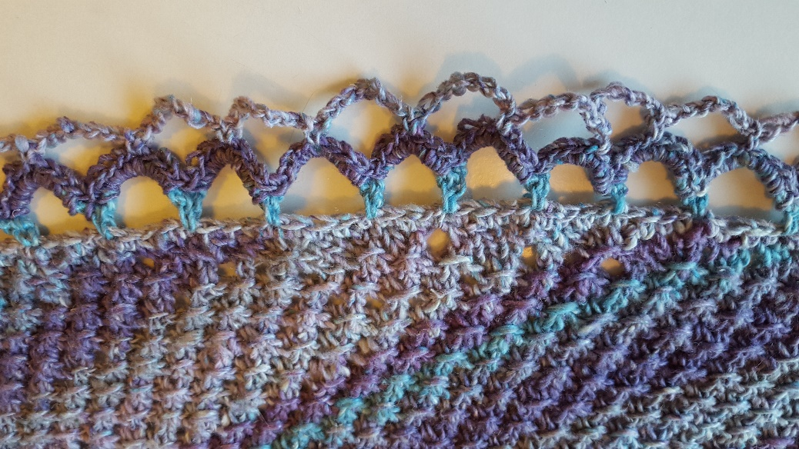
Row 5: 9 sc around each ch 7. Cut yarn.
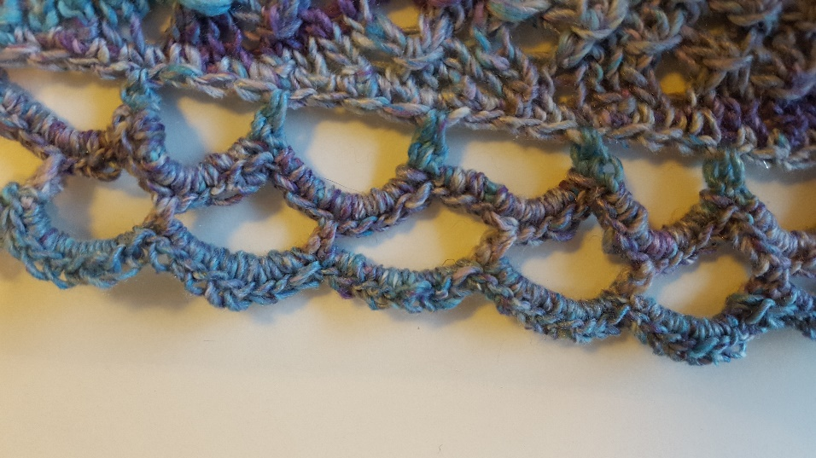

Round 6: From the right side: sl st in the first crochet st on the side, see pic (where the markers are), sc in each st until you reach the 5th sc of the “outer” chain. (see pic) *4 sc, in the top sc (5th) of the chain: (1 sc, picot (= ch 3, 1 sc in 1st chain) 1 sc), 4 sc* repeat *--* until the the last chain, and then continue making sc in all sc made until the first one, like in the beginning.
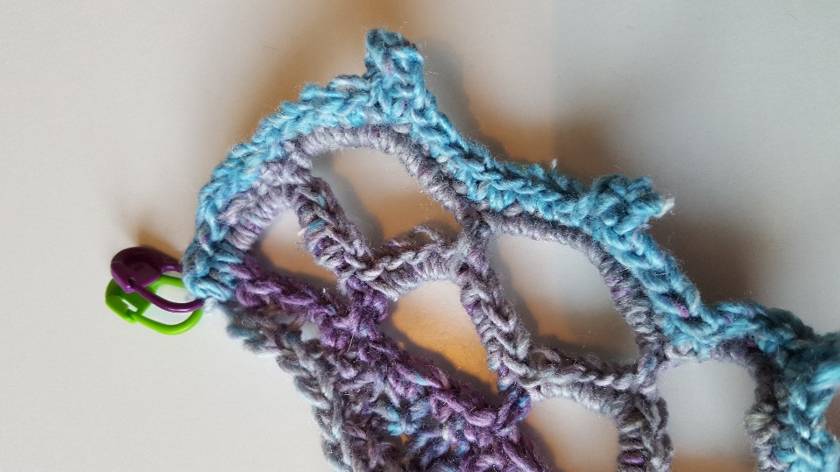
Weave in all ends and block the shawl. Done!
